Name: _______________________________________________
Higher Unit 6c topic test
Date:
Time: 50 minutes
Total marks available: 46
Total marks achieved: ______

Questions
Q1.
Here are three graphs.
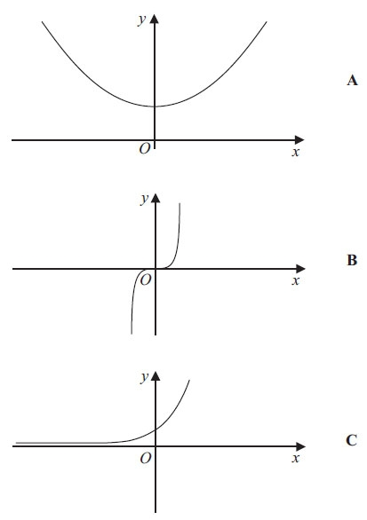
Here are four equations of graphs.
y = x³ y = x² + 4 y = ¹⁄_{x} y = 2^{x}

Match each to the correct equation.

A and y = . . . . . . . . . . . . . . . . . . . . .
B and y = . . . . . . . . . . . . . . . . . . . . .
C and y = . . . . . . . . . . . . . . . . . . . . .
(Total for Question is 3 marks)
Q2.
(a) Complete the table of values for y = x² – 4
x | −3 | −2 | −1 | 0 | 1 | 2 | 3
y |  | 0 | −3 |  |  | 0 | 5
(2)
(b) On the grid, draw the graph of y = x² – 4 for x = –3 to x = 3
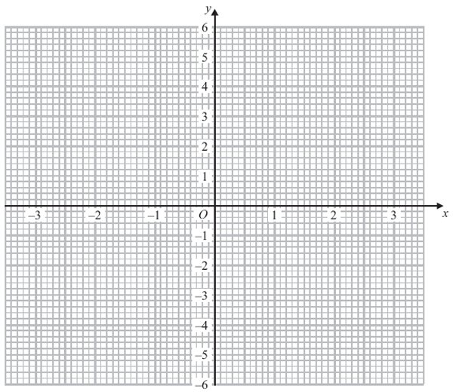
(2)
(Total for Question is 4 mark)

Q3.
(a) Complete the table of values for y = 2x² – 1
x | -2 | -1 | 0 | 1 | 2
y | 7 |  |  | 1
(2)
(b) On the grid below, draw the graph of y = 2x² – 1 for values of x from x = –2 to x = 2
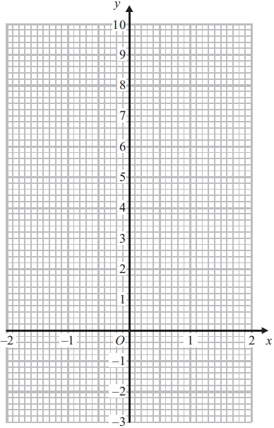
(2)
(c) Use your graph to write down estimates of the solutions of the equation 2x² – 1 = 0

..............................................................................................................................................
(2)
(Total for Question is 6 marks)

Q4.
(a) Complete the table of values for y = x² − 5x + 3
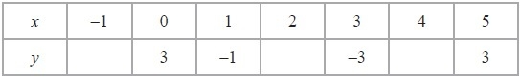
(2)
(b) On the grid below, draw the graph of y = x² − 5x + 3 for values of x from x = −1 to x = 5
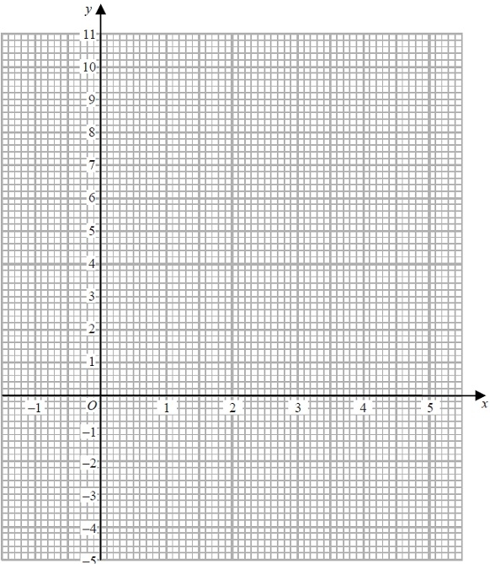
(2)

(c) Find estimates of the solutions of the equation x² − 5x + 3 = 0
x = ...........................................................
or x = ...........................................................
(2)
(Total for Question is 6 marks)

Q5.
(a) Complete the table of values for y = x² – 2x
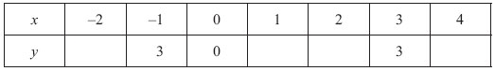

(2)
(b) On the grid, draw the graph of y = x² – 2x for values of x from –2 to 4
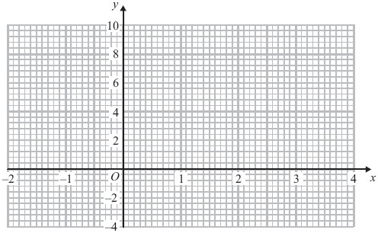
(2)
(c) Solve x² – 2x – 2 = 1

..............................................................................................................................................
(2)
(Total for Question is 6 marks)

Q6.
(a) Complete this table of values for y = x³ + 2x – 1
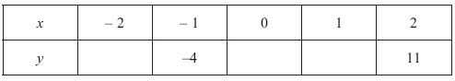

(2)
(b) On the grid, draw the graph of y = x³ + 2x – 1
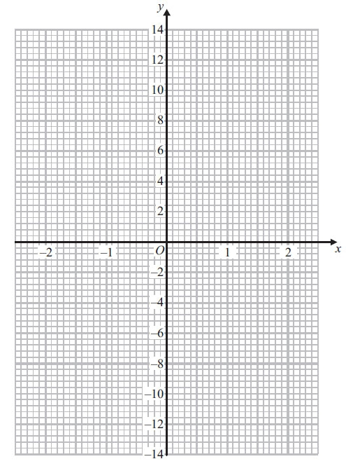
(2)
(Total for Question is 4 marks)
Q7.
(a) Complete the table of values for y = 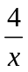
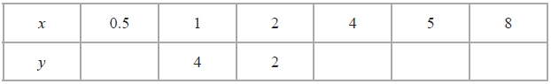
(2)
(b) On the grid, draw the graph of y = for 0.5 ≤ x ≤ 8
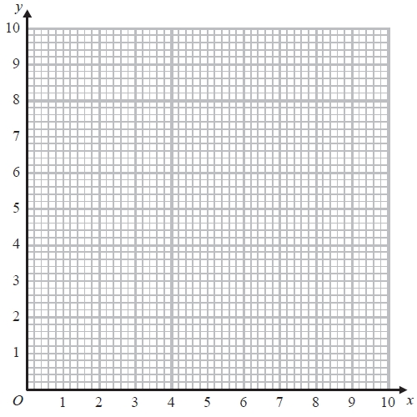
(2)
(Total for Question is 4 marks)

Q8.
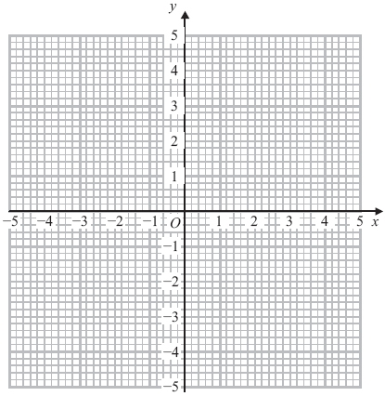
(a) On the grid, draw the graph of x² + y² = 4
(2)
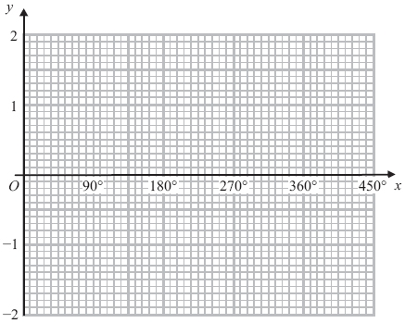
(b) On the grid, sketch the graph of y = cos x for 0° ≤ x ≤ 360°
(2)
(Total for Question is 4 marks)
Q9.
(a) Complete the table of values for y = x² − 2x − 1
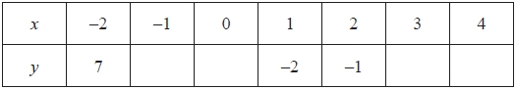
(2)
(b) On the grid, draw the graph of y = x² − 2x − 1 for values of x from −2 to 4
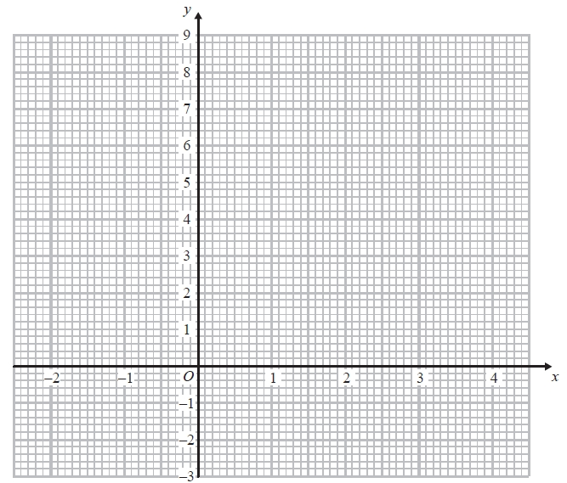
(2)
(c) Solve x² − 2x − 1 = x + 3
...........................................................
(2)
(Total for Question is 6 marks)

Q10.
(a) Complete the table of values for y = x³ − 4x
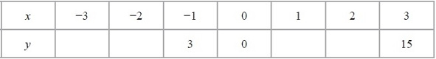
(2)
(b) On the grid, draw the graph of y = x³ − 4x from x = −3 to x = 3
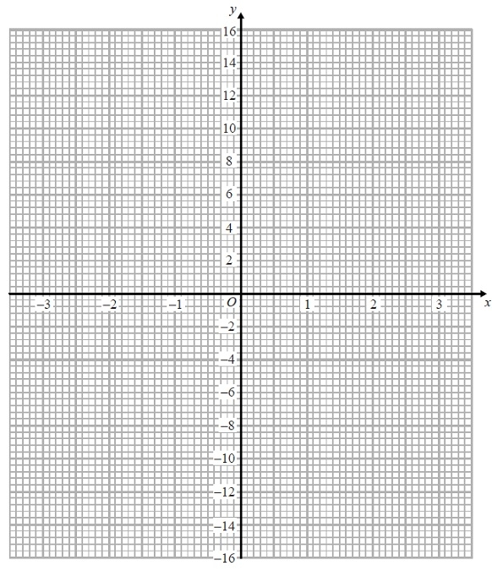
(2)
(Total for Question is 4 marks)
Examiner's Report
Q1.
This question was not well answered. The majority of candidates had little idea of the general shapes of the curves detailed in the specification. Curve A, y = x² + 4, was the most successful match. Some candidates did not seem to recognise the equation of the exponential curve and wrote y = 2x instead of y = 2^{x}. Commonly, there were attempts to plot graphs of the given equations, but this approach was not generally successful.

Q2.
This whole question was very well answered by the vast majority of candidates. In part (a), most candidates calculated the correct missing values; only a few weaker candidates got −5 instead of 5 for y when x = −3.
In part (b), the vast majority of candidates gained full marks for a good curve. Only a few used straight line segments, which prevented them from gaining full marks. Overall the quality of graph drawing was an improvement on previous years.

Q3.
Many values were given correctly in part (a). The most common error was in giving and answer of 3 or -3 for x=-1. Plotting points was quite well done in part (b); nearly all candidates realised that a curve was needed to join the points. Not all candidates knew how to answer part (c). Common errors included reading from the line y=1 or giving the solutions as coordinates rather than values. Few candidates marked the intersection with their curve to show where they were attempting to read off the values. Reading accurately was spoilt sometimes by poorly drawn curves.

Q4.
Most candidates scored at least one mark for their attempts to complete the table of values in part (a).
(−1. 7) was the most common error but full marks were still available in part (b) for accurate plotting and drawing of a smooth quadratic curve. Unfortunately many failed to secure both marks in part (b), usually through drawing a line segment between the points (2, −3) and (3, −3). Some candidates were very lazy in their curve drawing and many curves did not pass through their plotted points accurately enough. In part (c), many candidates chose not to use their graph and solved the quadratic equation by an alternative method. Although the correct solutions here did gain full marks, many made mistakes in the application of their method. It should be noted that for those candidates whose graph was more of a cubic form, ALL solutions (if not fully correct) were required.

Q5.
The only x value candidates had any difficulty with was x = -2, which usually led to an incorrect 0 for plotting. Though this was clearly wrong on the graph candidates still plotted this incorrect value.
A common error in part (b) was to leave the points unjoined, or to join them with straight line segments.
In part (c) few candidates realised the significance of the graph for finding the solutions, instead most preferred to solve them by either factorising or by using the formula method.

Q6.
The majority of candidates gained full marks for this question, finding the missing values and drawing a correct graph. Very few candidates failed to calculate at least one correct value. The points were usually accurately plotted although the point (2, 11) was sometimes plotted at (2, 13). Some candidates only gained one mark in part (b) as they joined the points with straight lines rather than drawing the curve freehand. Some did not join the points at all and some drew a line of best fit for the points. Curves were sometimes inaccurate, not passing through the points exactly or drawn with too thick a line or with several lines. Some candidates seemed to have pre-conceived ideas as to what the graph should look like and drew a parabola that contradicted their calculations.

Q7.
In part (a), many students were able to score at least 1 mark for working out 2 or more values in the table. Common errors were to work out 4 ÷ 0.5 as 2 and/or 4 ÷ 8 as 2.
In part (b), most students, having scored at least 1 mark in part (a), were then able to score a mark for correctly plotting 5 or 6 points from their table. A common error here was to join the points with straight line segments rather than with a smooth curve.

Q8.
Many candidates failed to attempt this question, and there were quite a number of attempts that failed to score any marks.
In part (a), many tried to draw a quadratic curve or a straight line. Some managed to draw part of a circle, or a circle with a radius of 4.
In part (b), many candidates ended up drawing a variant of the curve y = sin x. Some credit was given where it was clearly a cosine curve that was being attempted, but there were frequent errors in either amplitude or period.

Q9.
The values of y corresponding to positive values of x were generally worked out correctly. There was less success with the negative values, especially the value of y at = −1. In part (b) values were generally plotted accurately and the points joined with a smooth curve, although the occasional set of straight line segments was also seen. Part (c) proved beyond most candidates. Correct solutions were split between those who connected up the whole question and drew the straight line with equation y = x + 3. They were then able to pick out the required values of x for the two marks. Other candidates restarted, rearranged the equation and solved it, usually by factorisation. If the two values of x were given then the marks were awarded. Some candidates spotted that x = 4 satisfies the original equation, but without any of the two approaches shown they did not score any marks.

Q10.
Many correct answers to this question. The only common error in completing the table was use of 15 instead of −15. Plotting was good, though an opportunity to correct errors in the table were lost due to the failure to anticipate the correct shape of the graph. There were many errors in joining the points, with many using straight line segments or curves which missed joining the points.

Mark Scheme
Q1.
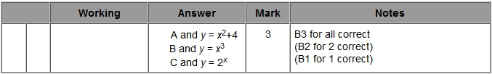

Q2.
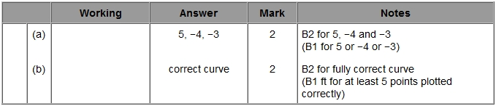

Q3.
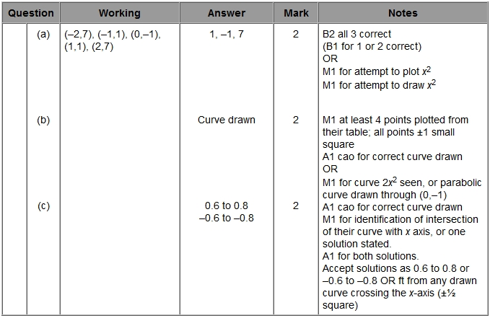

Q4.
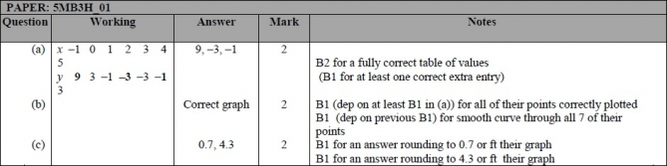

Q5.
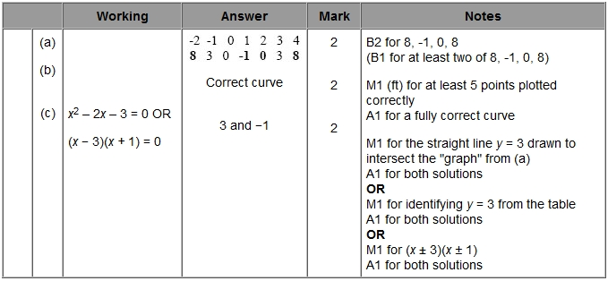

Q6.
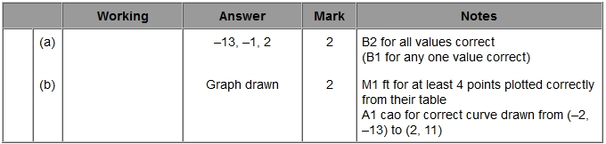

Q7.
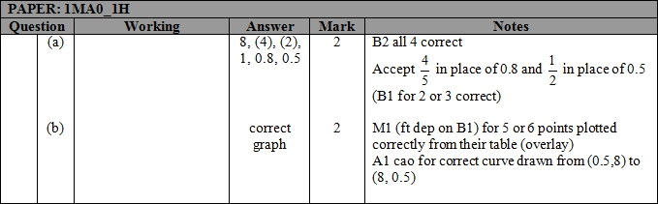

Q8.
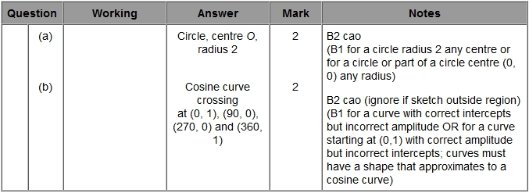

Q9.
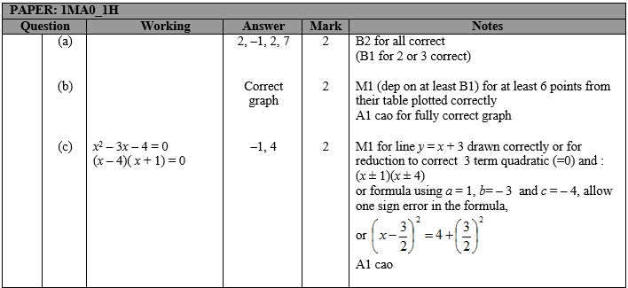

Q10.
